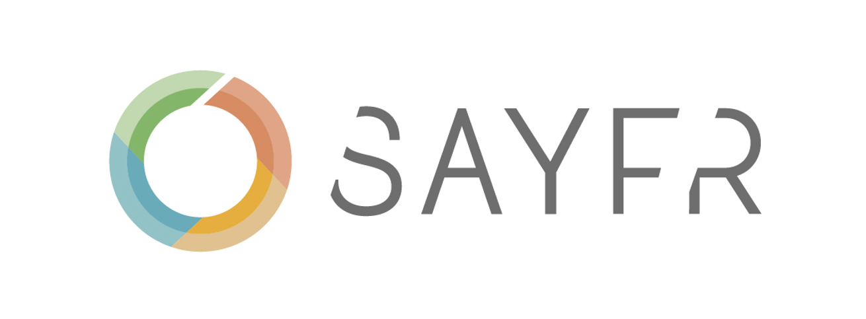

You’ve been invited to participate in the SafeMind Culture Survey Program. We’ve selected a few questions about your company's culture for you to answer. **The survey is conducted by Sayfr on behalf of [Company name].**

**The survey is anonymous** and will be treated with the strictest confidence to assure everybody's confidentiality.

Please use the link below to start the survey. The deadline for completing the survey is 2024-05-01

[safemind.sayfr.com/kdja13-fdk7-slfj38](http://safemind.sayfr.com/kdja13-fdk7-slfj38)

**Please note:** The link only allows for one response. Please do not share the link with anyone else.

If you are not able to answer all the questions click the 'Save & Exit' button. You can resume at any time using the same link.

If you experience any issues or have any questions about the program please contact your team leader or administrator.

Thank you for your participation!